NODE.JS

Server Side Javascript

Node.js – an intro
- In 2009 Ryan Dahl created Node.js or Node, a framework primarily used to create highly scalable servers for web applications.
  - Node.js is an open source, cross-platform runtime environment for server-side JavaScript.

  - Node.js is required to run JavaScript without a browser support. It uses Google V8 JavaScript engine to
execute code.
  - It is written in C++ and JavaScript.
  - Node.js is a development framework that is based on Google’s V8 JavaScript engine that powers
Google's Chrome web browser.
  - You write Node.js code in JavaScript, and then V8 compiles it into machine code to be executed.

  - It’s a highly scalable system that uses asynchronous, non-blocking I/O model (input/output), rather than threads or separate processes
  - It is not a framework like jQuery nor a programming language like C# or JAVA; Its primarily a Javascript engine

Node.js is really two things: a runtime environment and a library

Traditional Programming vs Event-driven programming
- In traditional programming I/O is performed in the same way as it does local function calls.
i.e. Processing cannot continue until the operation is completed.
- When the operation like executing a query against database is being executed, the whole
process/thread idles, waiting for the response. This is termed as “Blocking”
- Due to this blocking behavior we cannot perform another I/O operation, the call stack becomes frozen waiting for the response.

- Event-driven programming or Asynchronous programming is a programming style where
the flow of execution is determined by events.
- Events are handled by event handlers or event callbacks
  - An event callback is a function that is invoked when something significant happens like when the user clicks on a button or when the result of a database query is available.

- This style of programming — whereby instead of using a return value you define functions that are called by the system when interesting events occur — is called event-driven or asynchronous programming.
Typical blocking I/O
programming

result = query('SELECT * FROM posts WHERE id = 1'); do_something_with(result);
query_finished = function(result) {
do_something_with(result);
}
query('SELECT * FROM posts WHERE id = 1', query_finished);

Event loop
- An event loop is a construct that mainly performs two functions in a continuous loop —

event detection and event handler triggering.
  - In any run of the loop, it has to detect which events just happened.
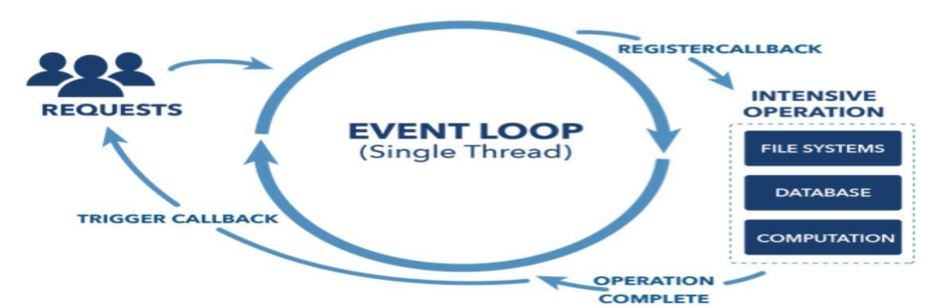
  - Then, when an event happens, the event loop must determine the event callback and invoke it.
- This event loop is just one thread running inside one process, which means that, when an event happens, the event handler can run without interruption. This means the following:
  - There is at most one event handler running at any given time.
  - Any event handler will run to completion without being interrupted.

  - Node.js uses the “Single Threaded Event Loop” architecture to handle multiple concurrent clients.

Asynchronous and Event Driven
- All APIs of Node.js library are asynchronous that is, non-blocking.
  - It essentially means a Node.js based server never waits for an API to return data.
  - The server moves to the next API after calling it and a notification mechanism of Node.js helps the server to get a response from the previous API call.
  - It is non-blocking, so it doesn't make the program wait, but instead it registers a callback and lets the program continue.

- Node.js is not fit for an application which performs CPU-intensive operations like image processing or other heavy computation work because it takes time to process a request and thereby blocks the single thread.
- Node.js is great for data-intensive applications.
  - Using a single thread means that Node.js has an extremely low-memory footprint when used as a web server and can potentially serve a lot more requests.
  - Eg, a data intensive application that serves a dataset from a database to clients via HTTP

- What Node is NOT!
Node is not a webserver. By itself it doesn't do anything. It doesn't work like Apache. There is no config file where you point it to you HTML files. If you want it to be a HTTP server, you have to write an HTTP server (with the help of its built-in libraries). Node.js is just another way to execute code on your computer.
It is simply a JavaScript runtime.

Setting up Node
- To install and setup an environment for Node.js :
  - Download the latest version of Node.js installable archive file from https://nodejs.org/en/
  - Double click to run the msi file
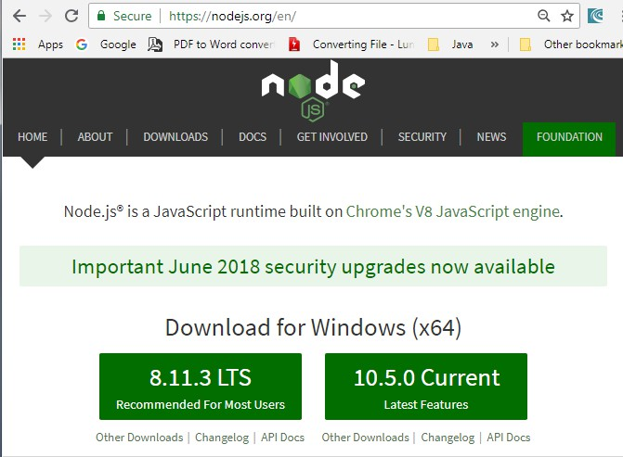

  - Verify if the installation was successful : node –v in command window.

Using the Node CLI : REPL (Read-Eval-Print-Loop)
- There are two primary ways to use Node.js on your machines: by using the Node Shell or by saving JavaScript to files and running those.
  - Node shell is also called the Node REPL; a great way to quickly test things in Node.
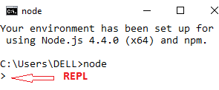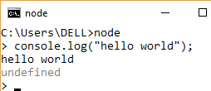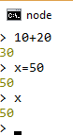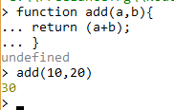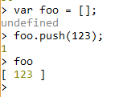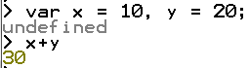
- When you run “node” without any command line arguments, it puts you in REPL
- You can also create a js file and type in some javascript.
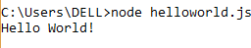
//helloworld.js console.log("Hello World!");

Using the REPL
- To view the options available to you in REPL type .help and press Enter.
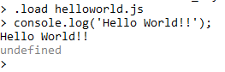
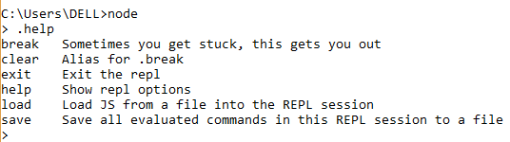
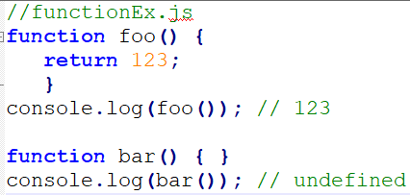
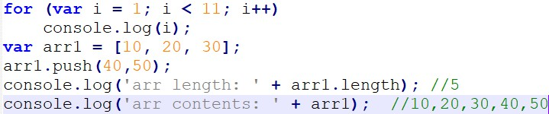
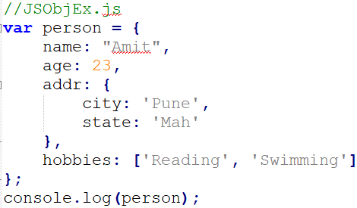
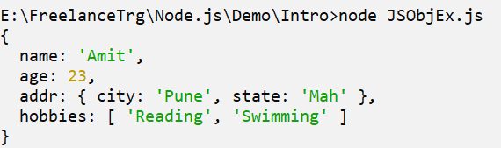

Node js Modules
- A module in Node.js is a logical encapsulation of code in a single unit.
  - Since each module is an independent entity with its own encapsulated functionality, it can be managed as a separate unit of work.

- Consider modules to be the same as JavaScript libraries.
  - A set of functions you want to include in your application.
  - Module in Node.js is a simple or complex functionality organized in JavaScript files which can be reused throughout a Node.js application.
  - A module is a discrete program, contained in a single file in Node.js. Modules are therefore tied to files,
with one module per file.

- Node.js has a set of built-in modules which you can use without any further installation.
  - Built-in modules provide a core set of features we can build upon.
  - Also, each module can be placed in a separate .js file under a separate folder.
  - To include a module, use the require() function with the name of the module.

- In Node, modules are referenced either by file path or by name
  - For example, we can require some native modules:
var http = require('http');
var dns = require('dns');
var myFile = require('./myFile'); // loads myFile.js

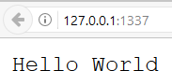
Node.js Web App
Import required module using require; load http module and store returned HTTP instance into http variable

//RunServer.js
var http = require("http");
createServer() : turns your computer into an HTTP server
Creates an HTTP server which listens for request over 1337 port on local machine

function process_request(req, res) { var body = ‘Hello World\n';
var content_length = body.length ; res.writeHead(200, {
'Content-Length': content_length, 'Content-Type': 'text/plain‘ });

res.end(body);
}

var srv = http.createServer(process_request); srv.listen(1337, '127.0.0.1’);

console.log('Server running at http://127.0.0.1:1337/');
var http = require('http'); http.createServer(function (req, res) {
res.writeHead(200, {'Content-Type': 'text/plain'});
res.end('Hello World\n');
})
.listen(1337, '127.0.0.1');

Node.js Module
- Node.js includes three types of modules:
  - Core Modules
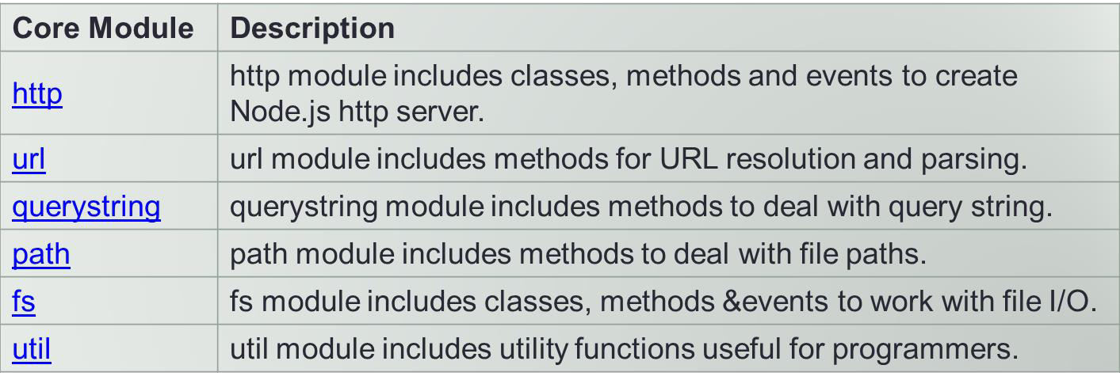
  - Local Modules
  - Third Party Modules

- Loading a core module
  - Node has several modules compiled into its binary distribution called core modules.
  - It is referred solely by the module name, not by the path and are preferentially loaded even if a third- party module exists with the same name.
  - var http = require('http’);
- Some of the important core modules in Node.js

Timers module
- Timer module is a core module.
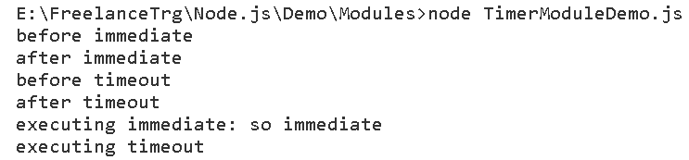
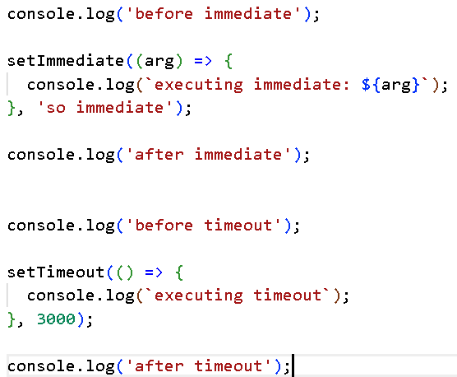
  - Timers module contains several functions that allow you to execute a block of code or a function after a specified amount of time.
  - You don't need to use require() to import the Timers module because it's global.
- Timer functions:
  - setImmediate(): executes code at the end of the current event loop cycle
  - setInterval(): defines a time interval.
  - setTimeout(): executes a one-time callback after delay milliseconds.
  - clearImmediate(immediateObject)
  - clearInterval(intervalObject)
  - clearTimeout(timeoutObject)

Node.js Local Module
- The local modules are custom modules that are created locally by developer in the app
  - These modules can include various functionalities bundled into distinct files and folders
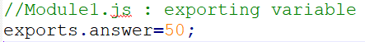
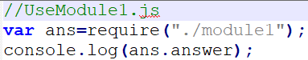
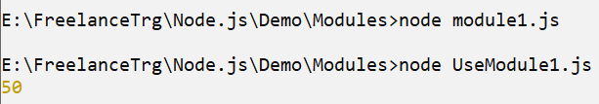
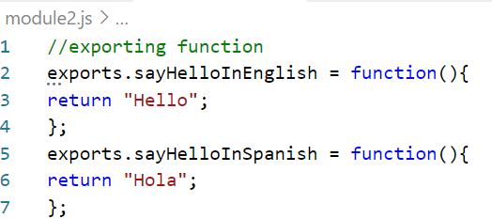
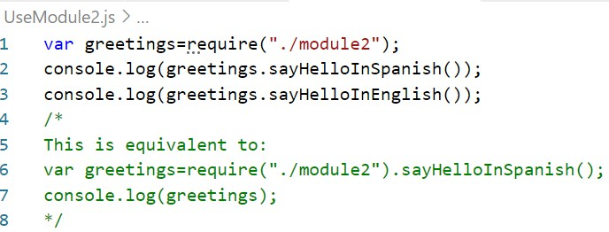
  - You can also package it and distribute it via NPM, so that Node.js community can use it.
  - For example, if you need to connect to MongoDB and fetch data then you can create a module for it, which can be reused in your application.

exports object is a special object created by the Node module system which is returned as the value of the require function when you include that module.

Create Your Own Modules

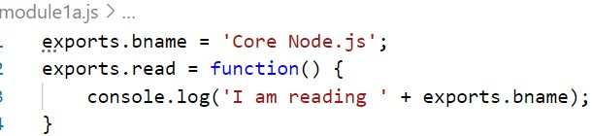
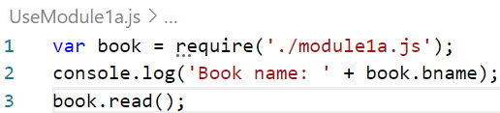
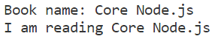
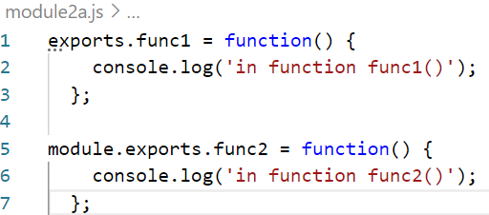
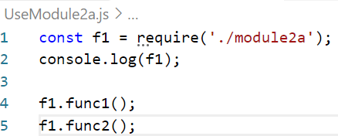
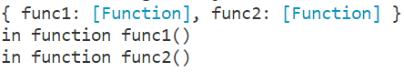
- Exports is just module.exports’s little helper. Your module returns module.exports to the caller ultimately, not exports. All exports does is collect properties and attach them to module.exports

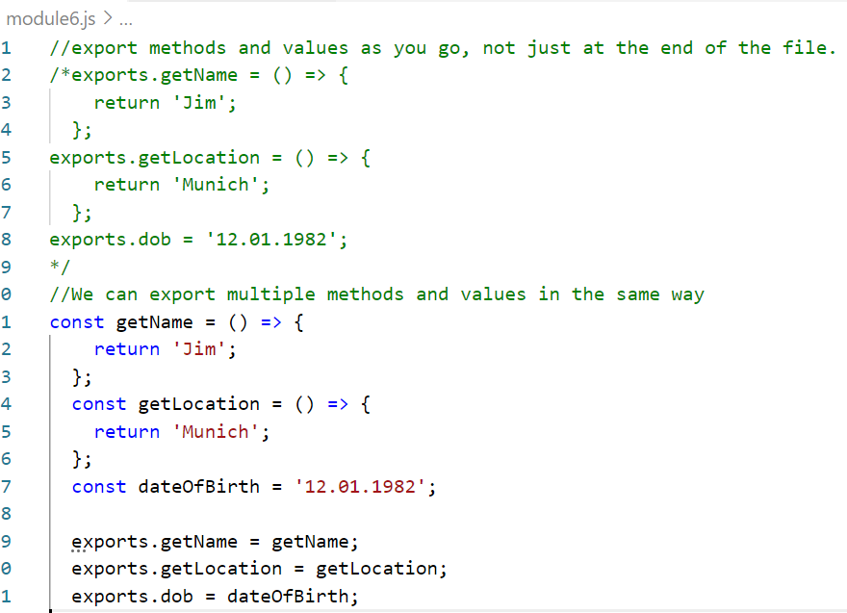
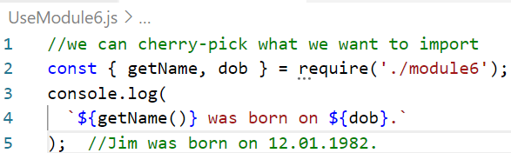
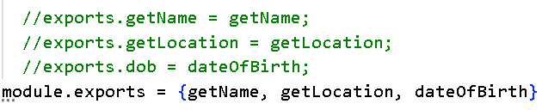
Example

Alternatively using module.exports

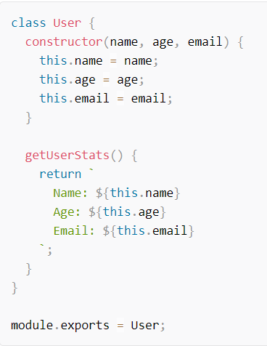
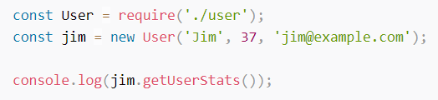
//module7.js function sayHello(){
console.log("Hello World!")
}

const username = 'Joan'

module.exports = {username, sayHello}

//or, using dot notation: module.exports.username = username module.exports.sayHello = sayHello

//alternatively exports.username = username exports.sayHello = sayHello
//import the assigned properties with a destructuring assignment: const { username, sayHello } = require(‘./module7’)

//Or with a regular assignment and dot notation: const helloModule = require(‘./module7')
helloModule.sayHello() console.log(helloModule.username)

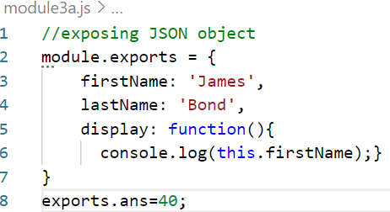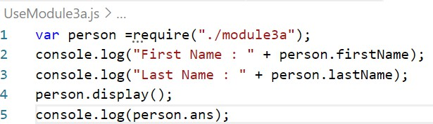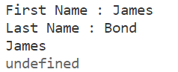
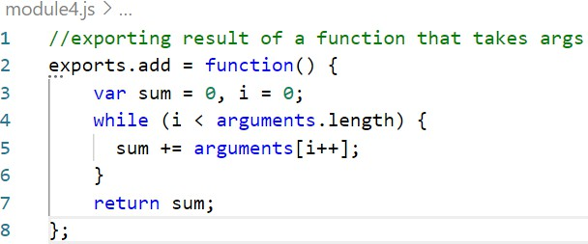
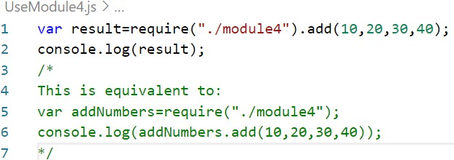
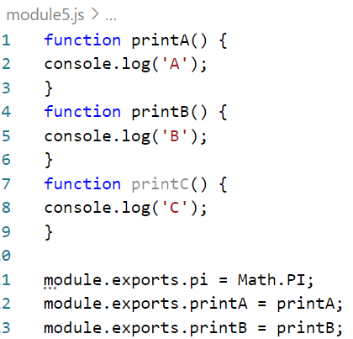
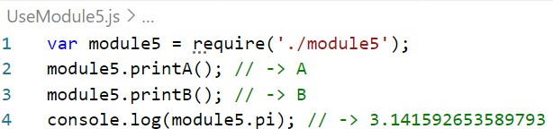

- Loading a module(Third party) installed via NPM
  - To use the modules written by other people in the Node community and published on the Internet (npmjs.com).
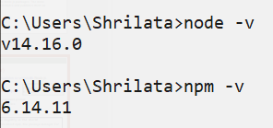
  - We can install those third party modules using the Node Package Manager which is installed by default with the node installation.
  - Node Package Manager (NPM) is a command line tool that installs, updates or uninstalls Node.js packages in your application.
  - It is also an online repository for open-source Node.js packages. The node community around the world creates useful modules and publishes them as packages in this repository.
  - NPM is a command line tool that installs, updates or uninstalls Node.js packages in your application.
  - After you install Node.js, verify NPM installation : npm -v

- Installing Packages
  - In order to use a module, you must install it on your machine.
  - To install a package, type npm install, followed by the package name

- There are two ways to install a package using npm: globally and locally.
- Globally − This method is generally used to install development tools and CLI based
packages. To install a package globally, use the following code.

npm install -g <package-name>
  - Eg to install expressJS : npm install -g express
  - Eg to install Typescript : npm install –g typescript
  - Eg to install Angular : npm install -g @angular/cli

- Locally − This method is generally used to install frameworks and libraries. A locally
installed package can be used only within the directory it is installed.
  - To install a package locally, use the same command as above without the -g flag.

npm install <package-name>
  - Eg : To install cookie parser in Express : npm install --save cookie-parser
  - Eg: to install bootstrap : npm install bootstrap@4.1.1

- When packages are installed, they are saved on local machine
- npm installs module packages to the node_modules folder.

- Installing a package using NPM : $ npm install [g] <Package Unique Name>

- To remove an installed package : npm uninstall [g] < Package Unique Name>

- To update a package to its latest version : npm update [g] < Package Unique Name>

- A linter is basically a parser that parses your code and looks for mistakes. It’s a great way to
save time, maintain quality and write safer code.
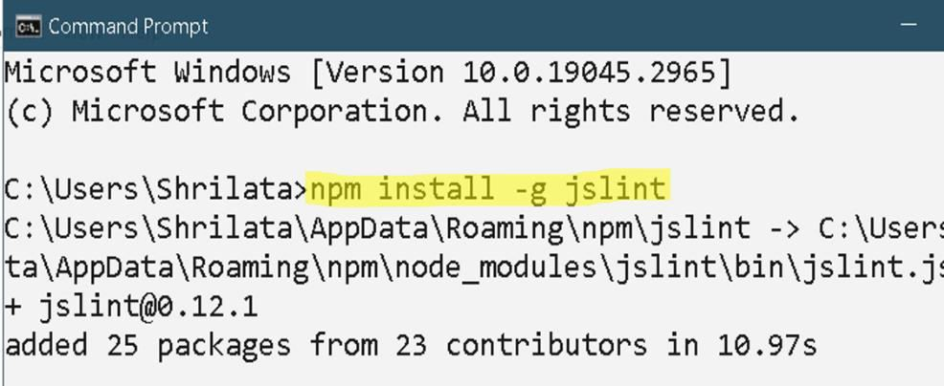
  - There are many linter tools for Javascript – JsLint, JsHint, EsLint, Jscs etc

- JSLint is a static code analysis tool used in software development for checking if JavaScript source code complies with coding rules
  - Static Code Analysis :a method of analyzing the source code without running them.
- JSLint is a JavaScript program that looks for problems in JavaScript programs. It is a code quality tool.
  - It takes a JavaScript source and scans it. If it finds a problem, it returns a message describing the problem.

- Install JSLint
Static analysis, also called static code analysis, is a method of computer program debugging that is done by examining the code without executing the program. The process provides an understanding of the code structure and can help ensure that the code adheres to industry standards. Static analysis is used in software engineering by software development and quality assurance teams. Automated tools can assist programmers and developers in carrying out static analysis.

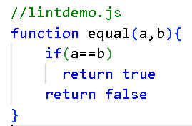
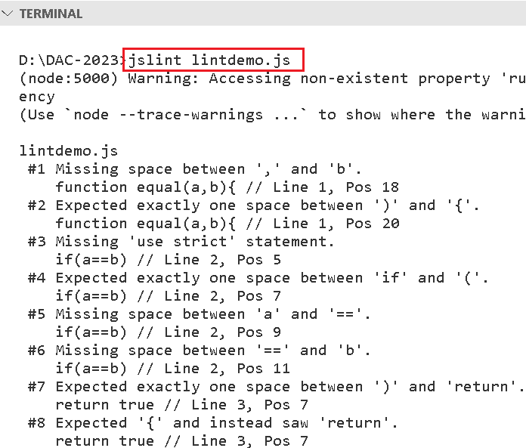
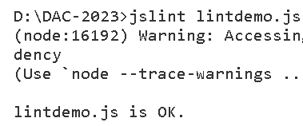

- Run JSLint on a JavaScript File

- After resolving issues:

//lintdemo.js
"use strict";
function equal(a, b) { if (a === b) {
return true;
}
return false;
}

- The package.json file in Node.js is the heart of the entire application.
  - It is basically the manifest file that contains the metadata of the project.
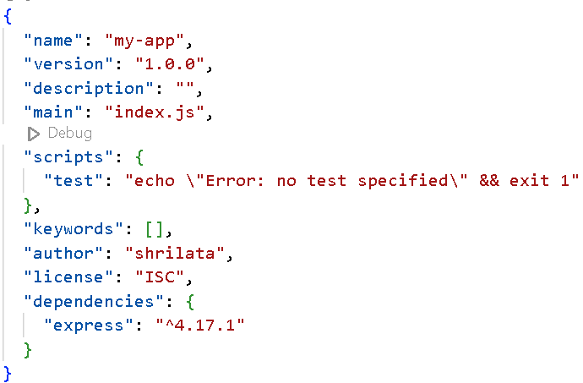
  - package.json is a configuration file from where the npm can recognize dependencies between packages
and installs modules accordingly.
  - It must be located in project’s root directory.
  - It contains human-readable metadata about the project (like the project name and description) as well as functional metadata like the package version number and a list of dependencies required by the application.
  - Your project also must include a package.json before any packages can be installed from NPM.
  - Eg : a minimal package.json:

    - package-lock.json file
      - Introduced in version 5; keeps track of the exact version of every package that is installed so that a product is 100% reproducible in the same way even if packages are updated by their maintainers.
      - The package-lock.json sets your currently installed version of each package in stone, and npm will use those exact versions when running npm install.

- Lets say I want to create a ExpressJS application. I will install ExpressJs locally.
  - Step-1) choose a empty folder
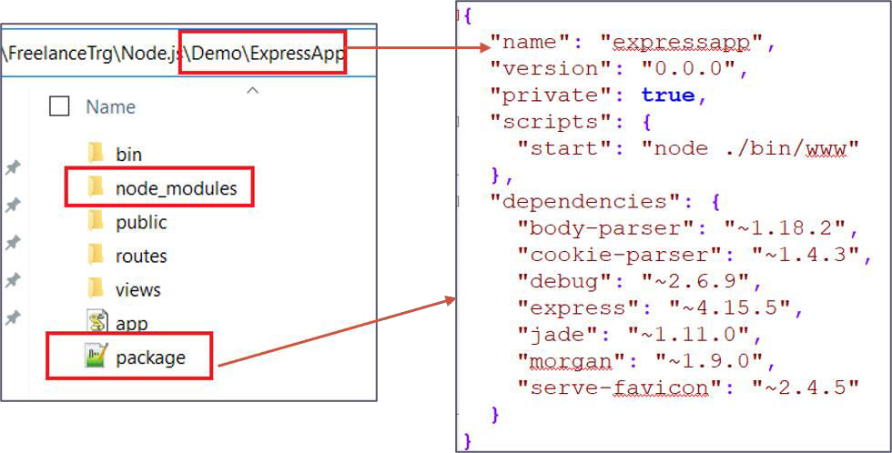
  - Step-2) run npm init to create a package.json file
  - Step-3) install express : npm install express –save (to update package.json)
  - Step-4) check the updated json file to see new dependencies

  - See how package.json is installed in root folder along with node_modules folder
  - My Express app is dependent on a number of other modules
  - All these dependencies will have an entry in package.json

- The fs module provides a lot of very useful functionality to access and interact with the file system.
  - There is no need to install it. Being part of the Node.js core, it can be used by simply requiring it:
  - const fs = require('fs')
- This module provides a wrapper for the standard file I/O operations.
- All the methods in this module has asynchronous and synchronous forms.
  - synchronous methods in this module ends with 'Sync'. For instance renameSync() is the synchronous method for rename() synchronous method.
  - The asynchronous form always take a completion callback as its last argument.
  - The arguments passed to the completion callback depend on the method, but the first argument is always reserved for an exception. If the operation was completed successfully, then the first argument will be null or undefined.

  - When using the synchronous form any exceptions are immediately thrown. You can use try/catch to handle exceptions or allow them to bubble up.
Asynchronous method is preferred over synchronous method because it never blocks the program execution where as the synchronous method blocks.

- Node fs module provides an API to interact with FileSystem and to perform some IO operations like create a file, read a File, delete a File etc..
  - fs module is responsible for all the async or synchronous file I/O operations.
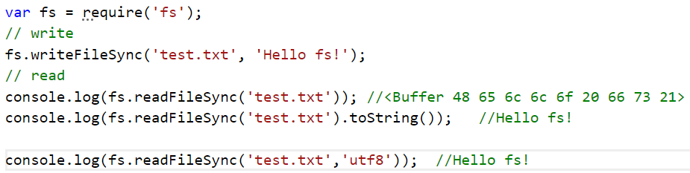
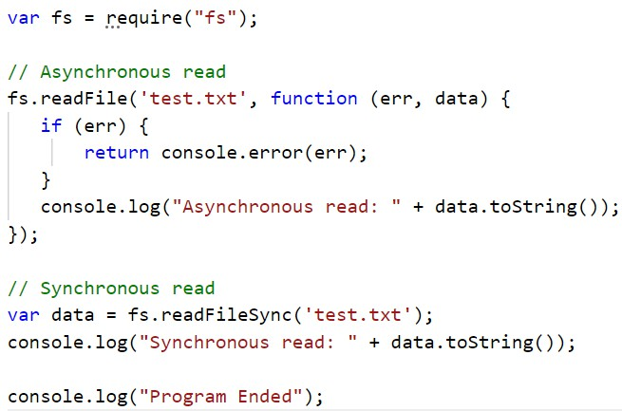
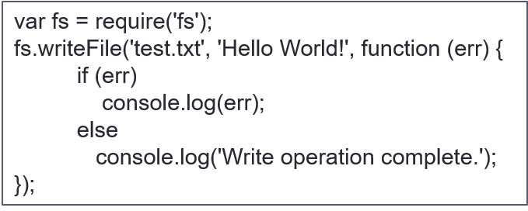
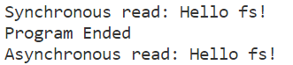

Node.js File System

fs.readFile(fileName [,options], callback) : read the physical file asynchronously.
- fs.writeFile(filename, data [, options], callback) : writes data to a file
- fs.appendFile(): appends the content to an existing file
- fs.unlink(path, callback); delete an existing file
var fs = require("fs") fs.unlink("test1.txt", function(err){
if(err) console.log("Err : " , err); console.log("delete successful")
})

- fs.exists(path, callback) : determines if specified file exists or not
- fs.close(fd, callback(err));
- fs.rename(oldPath, newPath, callback): rename a file or folder
fs.rename("src.json", "tgt.json", err => { if (err) {
return console.error(err)
}
console.log('Rename operation complete.');
});

Working with Directories
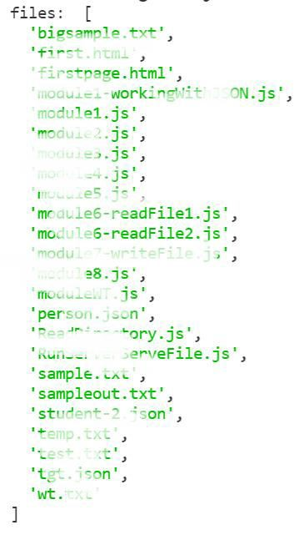
- fs.readdir() : lists all the files and directories within a specified path:
const fs = require('fs') fs.readdir('./', (err, files) => {
if (err) {
console.error(err) return
}
console.log('files: ', files)
})
if(!fs.existsSync('./newDir')){
fs.mkdir('./newDir',(err) => { if(err) console.log(err) console.log("Directory created!");
})
}
if(fs.existsSync('./newDir')){
fs.rmdir('./newDir',(err) => { if(err) console.log(err) console.log("Directory removed!");
})
}

Example
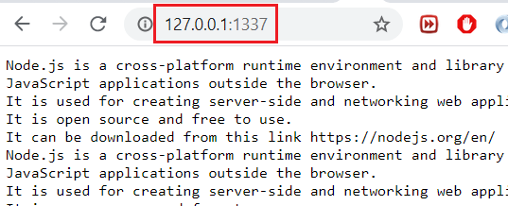
  - Reading a file at server end and serving to browser!
var http = require('http');
var fs = require('fs');
function process_request(req, res) { fs.readFile('bigsample.txt', function(err, data) {
res.writeHead(200, {'Content-Type': 'text/plain'}); res.write(data);
res.end();
});
}
var s = http.createServer(process_request); s.listen(1337, '127.0.0.1');
console.log('Server running at http://127.0.0.1:1337/');

Sending dynamic content to browser



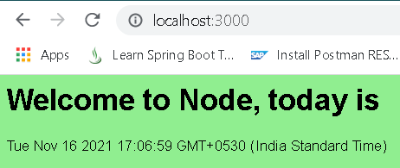
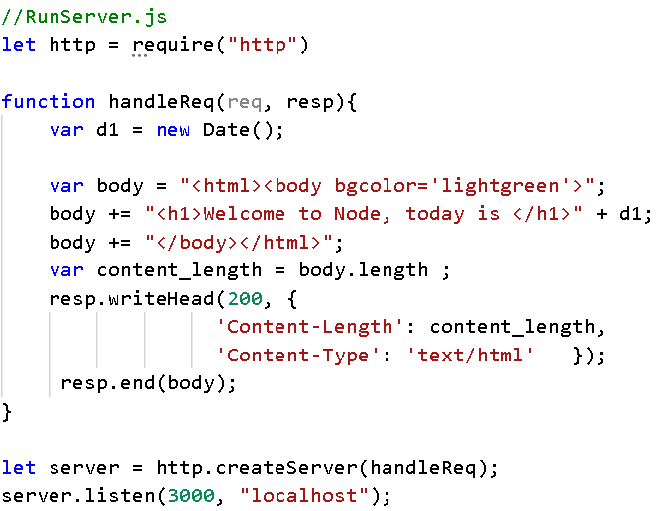
http://localhost:3000/

Browser

RunServer.js

Web development with Node : http.ServerRequest
- When listening for request events, the callback gets an http.ServerRequest object as the first argument (function(req,res))
- This object contains some properties:
  - req.url: This property contains the requested URL as a string
    - It does not contain the schema, hostname, or port, but it contains everything after that.
    - Eg : if URL is :http://localhost:3000/about?a=20 then req.url will return /about?a=20
  - req.method: This contains the HTTP method used on the request. It can be, for example, GET, POST, DELETE, or HEAD.
  - req.headers: This contains an object with a property for every HTTP header on the request.

Routing
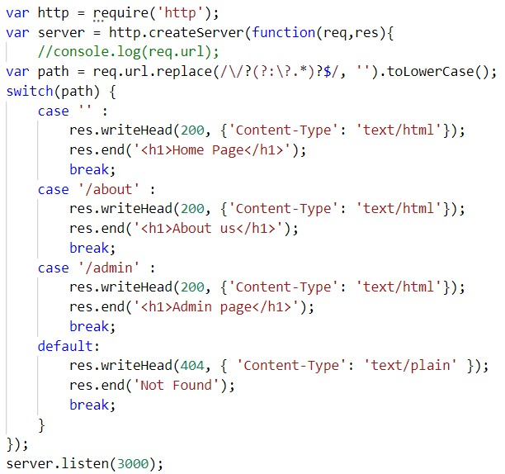
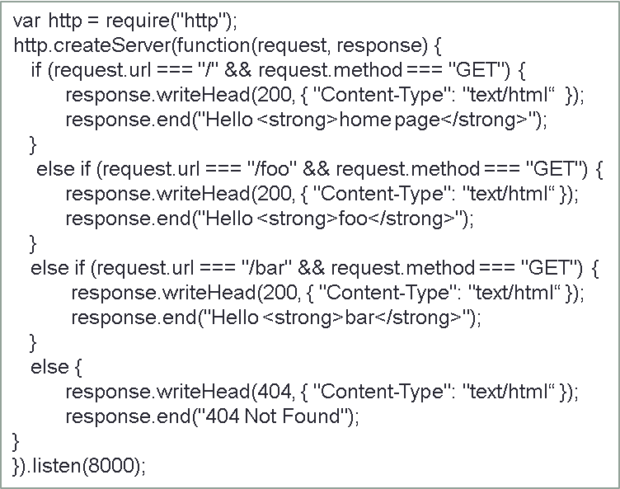
- Routing refers to the mechanism for serving the client the content it has asked

Handling GET req
var http = require('http'); var url = require('url'); var fs = require('fs');

function process_req(req, res) {
if (req.method == 'GET' && req.url == '/') { fs.readFile('radius.html', function(err, data) {
res.writeHead(200, {'Content-Type': 'text/html'}); res.write(data);
res.end();
});
<html>
<body>
<h1>Login</h1>
<form action="process">
Radius : <input name="radius">
<input type="submit"
value="Calc Radius">
</form>
</body></html>

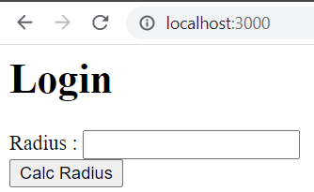
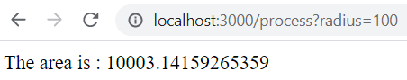
}
else if(req.method == 'GET' && req.url.substring(0,8) == '/process'){ var q = url.parse(req.url, true);
var qdata = q.query; var r = qdata.radius;
{ radius: '100' }

var rad = Math.PI + r * r;
res.writeHead(200, {'Content-Type': 'text/html'});
res.write("The area is : " + rad);
res.end();
}
else
res.end("not found");
}
var server = http.createServer(process_req)
server.listen(3000);
console.log('server listening on localhost:3000');

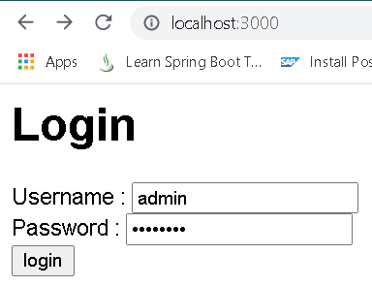
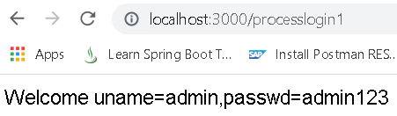
Handling POST req
.html', function(err, data) {
Content-Type': 'text/html'});
<body> //loginpost.html
<h1>Login</h1>
<form action="processlogin" method="post">
Username :
<input name="uname"><br> Password :
<input type="password"
name="passwd"><br>
<input type="submit"
value="login">
</form>
</body>

var http = require('http'); var fs = require('fs');

function process_req(req, res) {
if (req.method == 'GET' && req.url == '/') { fs.readFile('loginPost
res.writeHead(200, {' res.write(data); res.end();
});
}
else if(req.method == 'POST'){ var body = ""; req.on("data",function(data){
body += data;
res.writeHead(200, {'Content-Type': 'text/html'}); var arr = body.split("&");
res.write("Welcome " + arr);
res.end();
})
}
}
var server = http.createServer(process_req) server.listen(3000);
console.log('server listening on localhost:3000');
uname=admin&passwd=admin123

Promise
- Promises are a new feature of ES6.
  - It’s a method to write asynchronous code; it represents the completion of an asynchronous function.
  - It is a Javascript object that might return a value in the future.
  - It accomplishes the same basic goal as a callback function, but with many additional features and a more readable syntax.

- Creating a Promise
  - Promises are created by using a constructor called Promise and passing it a function that receives two parameters, resolve and reject, which allow us to indicate to it that it was resolved or rejected.
let promise = new Promise(function(resolve, reject) {
// executor code - things to do to accomplish your promise
});
let promise = new Promise(function(resolve, reject) {
// things to do to accomplish your promise

if(/* everything turned out fine */) { resolve('Stuff worked')
} else { // for some reason the promise doesn't fulfilled reject(new Error('it broke'))
}
})

- The promise we created earlier has fulfilled with a value, now we want to be able to access the value.
- Promises have a method called then() that will run after a promise reaches resolve in the
code.
- The then() method returns a Promise. It takes up to two arguments: callback functions for the success and failure cases of the Promise.
- Syntax : p.then(onFulfilled[, onRejected]);
  - onFulfilled function called if the Promise is fulfilled. This function has one argument, the fulfillment
value.

  - Example
promise.then(
function(result) { /* handle a successful result */ }, function(error) { /* handle an error */ }
);

promise.then(function(result) { console.log("Promise worked");
}, function(err) { console.log("Something broke");
});

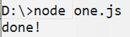
  - Full example

const promise = new Promise((resolve, reject) => {
if(true)
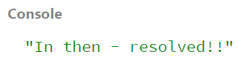
resolve("resolved!!")
});
promise.then(msg => console.log("In then - "+ msg))

let promise = new Promise(function(resolve, reject) { setTimeout(() => resolve("done!"), 3000);
});
// resolve runs the first function in .then
promise.then(
result =>console.log(result), //shows "done!" after 3 seconds
error =>console.log(error) // doesn't run
);
let promise = new Promise(function(resolve, reject) { setTimeout(() => reject(new Error("Whoops!")), 1000);
});

// reject runs the second function in .then promise.then(
result => alert(result), // doesn't run
error => alert(error) // shows "Error: Whoops!" after 1 second
);

- Alternatively, instead of using this syntax of then(fulfilled, rejected), you can also use catch()
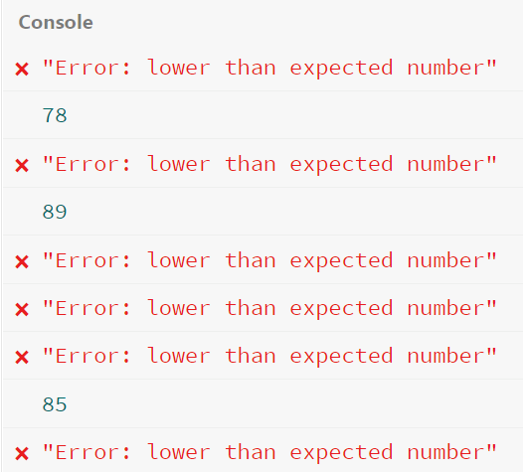
- The then and catch handlers are asynchronous.
  - Basically, then and catch will be executed once Javascript finished reading the code

promise.then(function(result) { console.log(result)
}).catch(function(err) {
console.log(err)
})

console.log('Hello world')
const promise = new Promise((resolve, reject) => {
// Note: only 1 param allowed return reject(‘Hi')
})

// Parameter passed into reject would be the arguments passed into catch.
promise.catch(err => console.log(err)) // Hi
function randomDelayed(max = 10, expected = 5, delay = 1000) { return new Promise((resolve, reject) => {
const number = Math.floor(Math.random() * max)

setTimeout(
() => number > expected
? resolve(number)
: reject(new Error('lower than expected number')), 1000
);
});
}
randomDelayed(100, 75, 2500)
.then(number => console.log(number))
.catch(error => console.error(error.toString()));

- The methods promise.then(), promise.catch(), and promise.finally() can be used to associate further action with a promise that becomes settled.
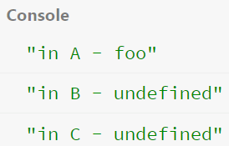
  - Each .then() returns a newly generated promise object, which can optionally be used for chaining

const myPromise = new Promise((resolve, reject) => { setTimeout(() => {
resolve('foo');
}, 300);
});

myPromise
.then(handleResolvedA, handleRejectedA)
.then(handleResolvedB, handleRejectedB)
.then(handleResolvedC, handleRejectedC);
const myPromise = new Promise((resolve) => { setTimeout(() => {
resolve('foo');
}, 300);
});

myPromise
.then((x)=>{console.log("in A - " + x);})
.then((x)=>{console.log("in B - " + x);})
.then((x)=>{console.log("in C - " + x);});
import fs from 'fs';

function readAFile(path) {
return new Promise((resolve, reject) => { fs.readFile(path, 'utf8', (error, data) => {
if (error) return reject(error);
return resolve(data);
});
});
}

readAFile('./file.txt')
.then(data => console.log(data))
.catch(error => console.error(error));

function myAsyncFunction(url) {
return new Promise((resolve, reject) => { const xhr = new XMLHttpRequest() xhr.open("GET", url)
xhr.onload = () => resolve(xhr.responseText) xhr.onerror = () => reject(xhr.statusText) xhr.send()
});
}

Ajax example with promise

- You'll see Promises used a lot when fetching data from an API
<!DOCTYPE html>
<html>
<body>
<div id="msg"></div>
<button id="btnGet">Get Message</button>
</body>
</html>
- Promises can be confusing, both for new developers and experienced programmers that have never worked in an asynchronous environment before.
- However, it is much more common to consume promises than create them. Usually, a browser’s Web API or third party library will be providing the promise, and you only need to consume it

function load(url) {
return new Promise(function (resolve, reject) { const request = new XMLHttpRequest(); request.onreadystatechange = function (e) {
if (this.readyState === 4) { if (this.status == 200) {
resolve(this.response);
} else {

reject(this.status);
}
}
}
request.open('GET', url, true);
request.send();
});
}
btn.onclick = function () {
load('data.json')
.then(
response => {
const result = JSON.parse(response);
$(“#msg”).text(result.message);
},
error => $(“#msg”).text(`Error getting message,
HTTP status: ${error}`
);
}

- One of the most useful and frequently used Web APIs that returns a promise is the Fetch API.
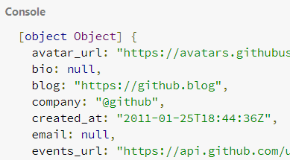
  - It allows you to make an asynchronous resource request over a network.
- fetch() is a two-part process, and therefore requires chaining then()
// Fetch a user from the GitHub API fetch('https://api.github.com/users/octocat')
.then((response) => { return response.json()
})
.then((data) => {
console.log(data)
})
.catch((error) => { console.error(error)
})

- async/await added in ECMAScript 2017 (ES8)
- async/await is built on promises
- async keyword put in front of a function declaration turns it into an async function
- An async function is a function that knows how to expect the possibility of the await keyword being used to invoke asynchronous code.
  - We use the async keyword with a function to represent that the function is an asynchronous function.
  - The async function returns a promise.
//simple synchromous JS function and invocation function hello() { return "Hello" };
hello();
//converting above JS function into async function async function hello() { return "Hello" }; hello();
// You can also create an async function expression like this:
let hello = async function() { return "Hello" };
hello();
//you can also use arrow functions:
let hello = async () => { return "Hello" };

- To consume the value returned when the promise fulfills (since it is returning a promise) use a
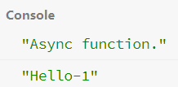
.then() block
//complete example async function hello(){
return "hello-1"
}
hello().then((x)=>console.log(x))
// returns"hello-1"
hello().then((value) => console.log(value))
//or even just shorthand such as hello().then(console.log)

let f = async () => { console.log('Async function.');
return Promise.resolve("Hello-1"); //function returns a promise
}
f().then(function(result) {
console.log(result)
});

The await keyword
async function logFetch(url) { try {
const response = await fetch(url); console.log(await response.text());
}
catch (err) {
console.log('fetch failed', err);
}
}
- The await keyword is used inside the async function to wait for the asynchronous operation
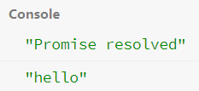
  - await can be put in front of any async promise-based function to pause your code on that line until the promise fulfills, then return the resulting value.
  - Syntax: let result = await promise;
  - You can use await when calling any function that returns a Promise, including web API functions
function logFetch(url) { return fetch(url)
.then(response => response.text())
.then(text => { console.log(text);
}).catch(err => { console.error('fetch failed', err);
});
}
// a promise
let promise = new Promise(function (resolve, reject) { setTimeout(function () {
resolve('Promise resolved')}, 4000);
});

async function asyncFunc() {// async function

// wait until the promise resolves let result = await promise;

console.log(result); console.log('hello');
}

asyncFunc(); // calling the async function

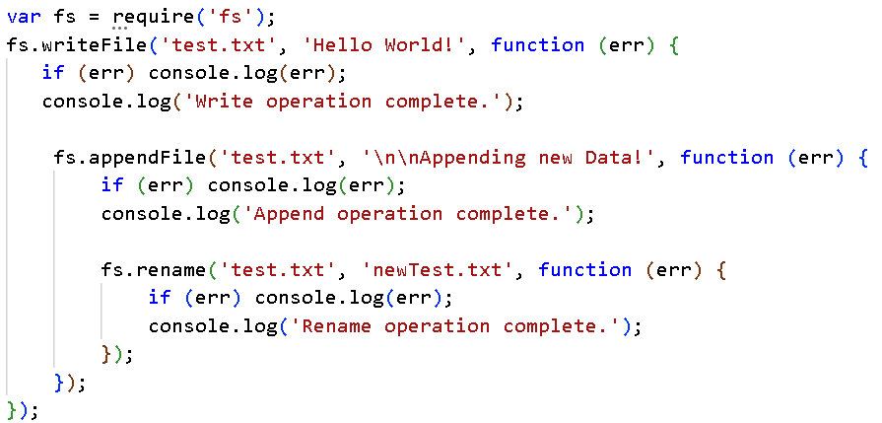

var fsPromises = require('fs').promises;

var fileOps = async() => { try{
await fsPromises.writeFile("test.txt", "Hello Promises!");
await fsPromises.appendFile("test.txt", "\nSome more content!");
await fsPromises.rename("test.txt", "newTest.txt");
var data = await fsPromises.readFile("newTest.txt", "utf8"); console.log(data);
}
catch(err){  console.error(err);  }  } | fs.promises contains a subset of the interface for what's on fs, but with promise-based interfaces instead of plain callback-style interfaces.
fileOps()

Axios
- Making API calls is integral to most applications
- Axios is a popular HTTP client available as a JavaScript library with more than 22 million
weekly downloads as of May 2022.
  - We can make API calls with Axios from JavaScript applications irrespective of whether the JavaScript is running on the front-end or the server-side.

- Why do we need to use a library like Axios when JavaScript already provides built-in objects: XMLHttpRequest and the Fetch API for interacting with APIs
  - Axios in contrast to these built-in objects is an open-source library that we need to include in our application for making API calls over HTTP.
  - It is similar to the Fetch API and returns a JavaScript Promise object but also includes many powerful features.
  - Axios makes it easy to send asynchronous HTTP requests to REST endpoints and perform CRUD
operations.
  - It can be used in plain JavaScript or with a library such as Vue or React.

  - Axios works both in the browser and in a Node.js environment.
  - On the server-side it uses the native node.js http module, while on the client (browser) it uses XMLHttpRequests

Insta ling Axios
- We can add Axios to our project/code with one of following simple ways:
  - Using npm: npm install axios
  - Using jsDelivr CDN: <script src="https://cdn.jsdelivr.net/npm/axios/dist/axios.min.js"></script>

- Making an HTTP request - simply pass a config object to the axios() function.
- Example:

- Axios also provides a set of shorthand methods for performing different types of requests.
// Send a POST request
axios({
method: 'post', url: '/user/12345', data: {
firstName: 'Fred', lastName: 'Flintstone'
}
});
- The methods include:
  - axios.request(config)
  - axios.get(url[, config])
  - axios.delete(url[, config])
  - axios.head(url[, config])
  - axios.options(url[, config])
  - axios.post(url[, data[, config]])
  - axios.put(url[, data[, config]])
  - axios.patch(url[, data[, config]])
axios.post('/login', { firstName: 'Finn', lastName: 'Williams'
});

- Following are some of the available config options for making requests.
  - Only the url is required.
  - Requests will default to GET if method is not specified.
{
url: '/user', // the server URL that will be used for the request method: 'get', // request method to make the request; default - get transformRequest: [function (data, headers) {
// Do whatever you want to transform the data
// only applicable for 'PUT', 'POST', 'PATCH' & 'DELETE' return data;
}],
transformResponse: [function (data) {
// Do whatever you want to transform the data return data;
}],
// `data`:the data to be sent as the request body
// Only applicable for 'PUT', 'POST', 'DELETE', and 'PATCH' data: {
firstName: 'Fred'
},…
}

- The response for a request contains the following information:

using then, you will receive the response as follows:
axios.post('/login', { firstName: ‘Anita', lastName: ‘Patil'
})
.then((response) => { console.log(response);
}, (error) => { console.log(error);
});
axios.get('/user/12345')
.then(function (response) { console.log(response.data); console.log(response.status); console.log(response.statusText); console.log(response.headers); console.log(response.config);
});
{
data: {}, //the response coming from server status: 200, // response status code statusText: 'OK', //response status message headers: {}, //response headers
config: {}, //the config that was provided for the request
}

- When

If the promise is fulfilled, the first argument of then() will be called; if the promise is rejected, the second argument will be called.

- Using Axios in a simple CRUD service component:
const baseUrl = 'http://localhost:8080/course/courses'
class CourseService{ getCourses(){
return axios.get(baseUrl)
}
getCourseById(id){
return axios.get(baseUrl+"/"+id)
}
updateCourse(course){
return axios.put(baseUrl+"/"+course.id,course)
}
addCourse(course){
return axios.post(baseUrl,course)
}
deleteById(id){
return axios.delete(baseUrl+"/"+id)
}
}

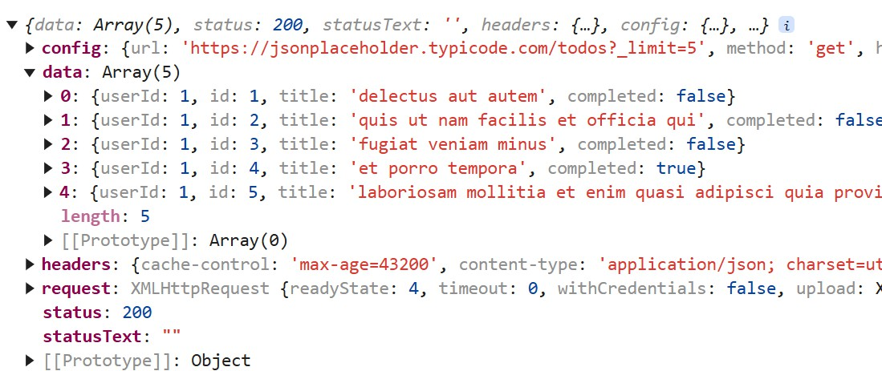
- Lets see a simple example: See what console shows
function getTodos() {
axios
.get('https://jsonplaceholder.typicode.com/todos?_limit=5')
.then(response => console.log(response))
}

- axios.post(url, data) – takes 2 required parameters - url to connect to server and Data to post to server.
data is a JS object which will be converted to JSON by axios
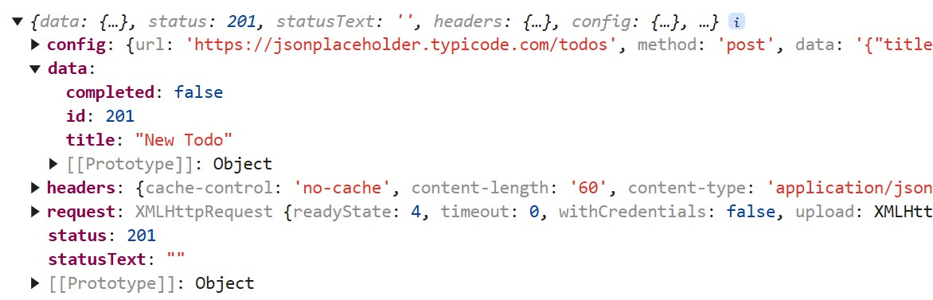
function addTodo() { axios
.post('https://jsonplaceholder.typicode.com/todos', { title: 'New Todo',
Response object
in console
completed: false
})
.then(res => console.log(res))
}

This is some dummy data that API returns for some pseudo successful save

Axios Error handling
Incorrect URL
- Use catch() for handling errors

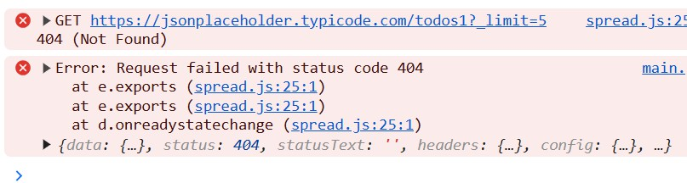
function getTodos() {
axios
.get('https://jsonplaceholder.typicode.com/todos1?_limit=5')
.then(response => console.log(response))
.catch(err => console.error(err, err.response));
}

.catch(function (error) {
if (error.response) { // get response with a status code not in range 2xx
console.log(error.response.data); console.log(error.response.status); console.log(error.response.headers);
}

EXPRESS.JS

Node.js web application framework

Introduction
- If you write serious apps using only core Node.js modules you will find yourself reinventing the wheel by writing the same code continually for similar tasks, such as the following:
  - Parsing of HTTP request bodies and Parsing of cookies

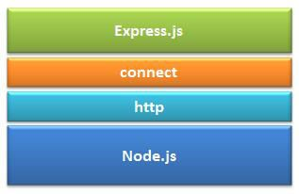
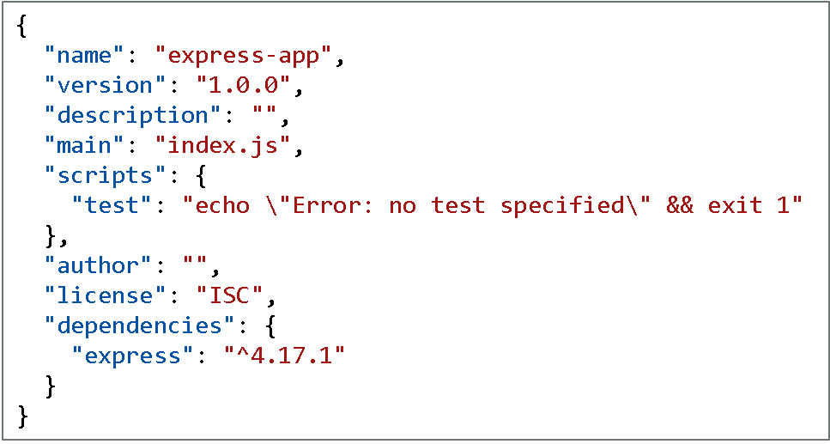
  - Managing sessions
  - Organizing routes with a chain of if conditions based on URL paths and HTTP methods of the requests
  - Determining proper response headers based on data types

- Express is a web application framework for Node
  - Its built on top of Node.js.
  - It provides various features that make web application development fast and easy compared to Node.js.

- Express.js Installation
  - Create a new folder: eg E:\Express-app
  - E:\Express-app>npm init //for creating package.json
  - E:\Express-app>npm install express --save

First app
- An Express app is created by calling the express() function
  - express() : Creates an Express application; is a top-level function exported by the express module
  - The app object conventionally denotes the Express application.
  - This object, which is traditionally named app, has methods for routing HTTP requests, configuring middleware, rendering HTML views, registering a template engine, and modifying application settings that control how the application behaves

let express = require("express") // import the express module
let app = express() // create an Express application app.get("/",function(req,resp){
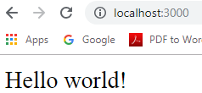
resp.send("Hello world")
})

app.listen(3000, function(){ console.log("app running on port 3000")
})
The app.listen() method returns an http.Server object

- HTTP verb and URL combinations are referred to as routes, and Express has efficient syntax for handling them.

var express = require("express"); var http = require("http");
var app = express();

app.get("/", function(req, res, next) {
res.send("Hello <strong>home page</strong>");
Open browser and type: http://localhost:3000 http://localhost:3000/foo http://localhost:3000/bar http://localhost:3000/admin - gives error

});

app.get("/foo", function(req, res, next) { res.send("Hello <strong>foo</strong>");
});

app.get("/bar", function(req, res, next) {
res.send("Hello <strong>bar</strong>");
});
//app is passed to the http.createServer() method http.createServer(app).listen(8000);

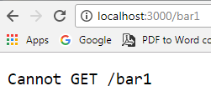
- If none of your routes match the request, you'll get a
"Cannot GET <your-request-route>" message as response.
- This message can be replaced by a 404 not found page using this simple route

 | app.get('*', function(req, res){ res.send('Sorry, this is an invalid URL.');  }); | app.get(‘/course/:id', function(req, res){ var course = //code to retrieve course If(!course){  res.status(404).send(“course not found”);  });
app.get("/", function(req, res, next) {
res.send("Hello <strong>home page</strong>");
});
  - The get() method defines routes for handling GET requests.
  - Express also defines similar methods for the other HTTP verbs (put(), post(), delete(),
and so on).
    - app.method(path, handler) : This METHOD can be applied to any one of the HTTP verbs – get, post, put, delete.
    - The path is a string or regular expression representing the URL that the route responds to. Note
that the query string is not considered part of the route’s URL.
  - Also notice that we haven’t defined a 404 route, as this is the default behavior of Express when a request does not match any defined routes.

app.get("/", function(req, res, next) {
res.send("Hello <strong>home page</strong>");
});

- Express also augments the request and response objects with additional methods. Example response.send() .
- send() is used to send a response status code and/or body back to the client.
- If the first argument to send() is a number, then it is treated as the status code. If a status code is not
provided, Express will send back a 200.
- The response body can be specified in the first or second argument, and can be a string, Buffer, array, or object.

- send() also sets the Content-Type header unless you do so explicitly.
- If the body is a string, Express will set the Content-Type header to text/html.
- If the body is an array or object, then Express will send back JSON.
- If the response body is a Buffer, the Content-Type header is also set to application/octet-stream

var express = require("express"); var app = express();
var path = require('path');

app.get("/buff", function(req, res, next) { var buff = Buffer.from("Hello World"); res.send(buff.toString());
});
app.get("/string", function(req, res, next) { res.send("Hello <strong>String response</strong>");
});
app.get("/json", function(req, res, next) {
res.send({name:'Soha',age:23});
});
app.get("/array", function(req, res, next) { res.send(['NodeJS','Angular','ExpressJS']);
});
app.get("/file", function(req, res, next) {
res.sendFile(path.join( dirname + '/summer.html'));
});
app.listen(3000);

Working with parameters using get

req.query
    - Express parses query string parameters by default, and puts them into the req.query property.
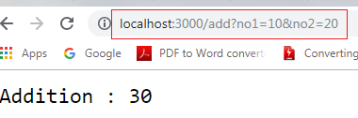
    - If the request is GET /search?username=Shrilata
req.query.username returns “Shrilata"

    - Lets say the incoming url is : http://localhost:3000/add?no1=10&no2=20
    - Use req.query to query the request parameters
app.get("/add", function (req, res) { n1 = parseInt(req.query.no1);
n2 = parseInt(req.query.no2); res.end("Addition : " + (n1 + n2) );
});

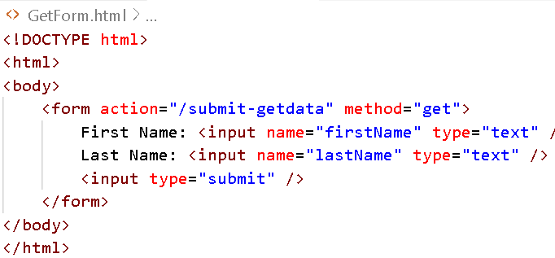
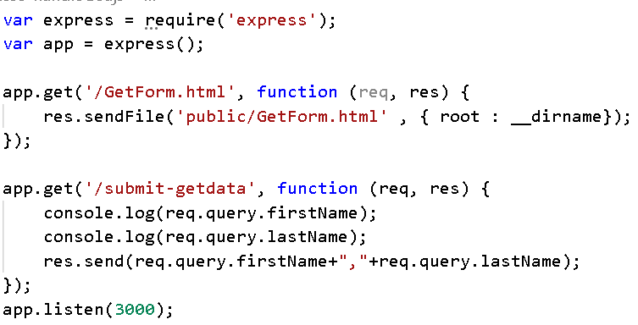
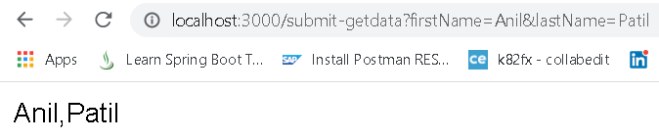
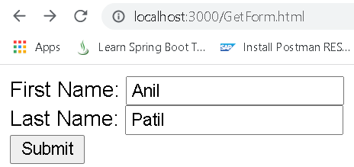
Handle GET Request

Multiple different methods
  - We can also have multiple different methods at the same route.
var express = require('express');
var app = express();

app.get('/hello', function(req, res){ res.send("Hello World!");
});

app.post('/hello', function(req, res){
res.send("You just called the post method at '/hello'!\n");
});

app.delete('/hello', function(req, res){
res.send("You just called the delete method at '/hello'!\n");
});

app.listen(3000);

Handle POST Request
  - To handle HTTP POST request in Express.js version 4 and above, you need to install a middleware module called body-parser.
    - This is used to parse the body of requests which have payloads attached to them.

    - Install it using : npm install --save body-parser
    - Mount it by including the following lines in your js
var bodyParser = require("body-parser"); app.use(bodyParser.urlencoded({ extended: false }));

    - This body-parser module parses the JSON, buffer, string and url encoded data submitted using HTTP POST request.
    - Eg :To parse json data: app.use(bodyParser.json())
bodyParser.urlencoded(): Parses the text as URL encoded data (which is how browsers tend to send form data from regular forms set to POST) and exposes the resulting object (containing the keys and values) on req.body

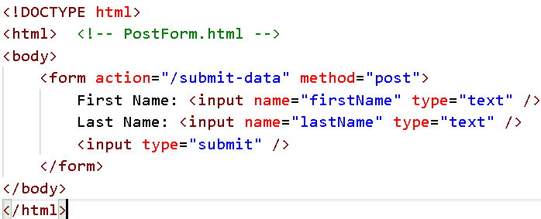
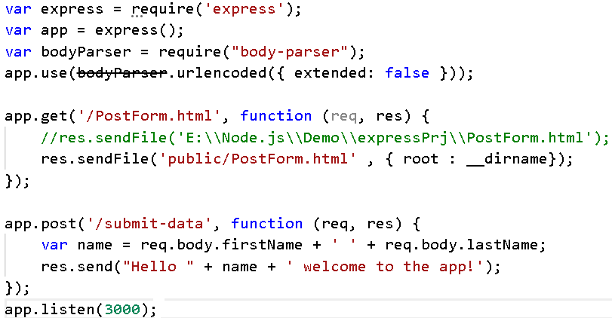
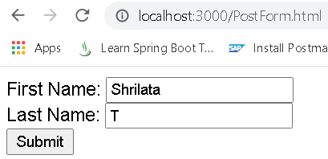
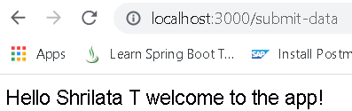
Handle POST Request

Route Parameters
- One of the most powerful features of routing is the ability to use placeholders to extract named values from the requested route, marked by the colon ( :) character.
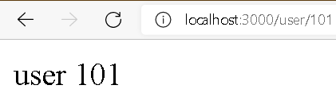

  - When the route is parsed, express puts the matched placeholders on the req.params object for you.
app.get('/user/:id', function(req, res) { res.send('user ' + req.params.id);
});

app.get(‘/product/:prodname', function(req, res) {
res.send(‘Product : ' + req.params.prodname);
});

Placeholders match any sequence of
characters except for forward slashes.

REST WITH EXPRESS

Example
- npm install body-parser –save
  - body-parser middleware helps us decode the body from an HTTP request: It parses the body of the request and lets us react to it
- npm install cors –save
  - cross-origin resource sharing : Since we are calling the API from different locations by hitting endpoints in the browser. We also have to install the CORS middleware.
var express = require('express'); var app = express();
const bodyParser = require('body-parser');
const cors = require('cors'); //cross-origin resource sharing

// Configuring body parser middleware app.use(bodyParser.urlencoded({ extended: false })); app.use(bodyParser.json());

let courses = [{id:1,name:'Java'},
{id:2,name:'AJAX'},
{id:3,name:'Angular’}
];

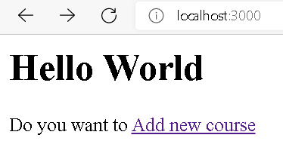
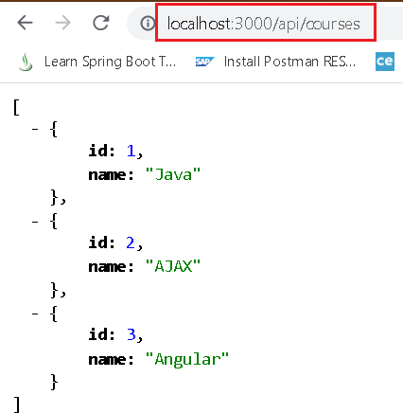
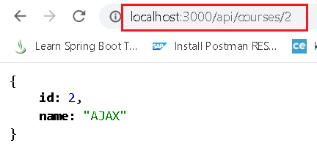
app.get('/', function(req, res){ let str = "<h1>Hello World </h1>"
str += "Do you want to <a href='AddCourse.html'>Add new course</a>"
res.send(str);
});

app.get('/AddCourse.html', function(req, res){ res.sendFile('AddCourse.html' , { root : dirname});
});

app.get('/api/courses', function(req, res){ res.send(courses);
});

//logic to look for a course with given id
app.get('/api/courses/:id', function(req, res){
var course;
for(i in courses){
if(courses[i].id == parseInt(req.params.id)){ console.log("found ");
course = courses[i];
}
}
res.send(course);
});

app.post('/api/courses',function(req,res){ let obj = req.body
obj.id = courses.length+1 courses.push(obj);
res.send("Added course : " + JSON.stringify(obj));
});

app.delete('/api/courses/:id', function(req, res){
var course, index=0;
for(c in courses){
if(courses[c].id == parseInt(req.params.id)){ console.log("course found for delete"); course = courses[c];
index++;
<body>
} <form method="post" action="api/courses">
} New Course Name : <input name="name"><br>

courses.splice(index-1,1)
res.send("course with id " + req.params.id
+ " deleted");
<input type="submit" value="Add course">
</form>
</body>

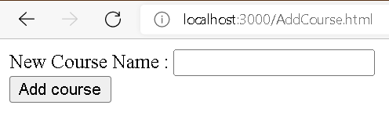
});

app.listen(3000);

Method | URL endpoint | what it does
get | localhost:3000 | fetch home page
get | localhost:3000/AddCourse.html | fetch AddCourse.html
get | localhost:3000/api/courses | fetch all courses
get | localhost:3000/api/courses/2 | fetch course with given ID
post | localhost:3000/api/courses | create course
delete | localhost:3000/api/courses/2 | delete course with given Id

Mongodb with mongoose :CRUD Operations Using Mongoose
- Mongo is a document-oriented database that stores data in BSON formatted documents.
- To access Mongo from within a Node/Express application, a driver is required.
- There are a number of Mongo drivers available, but MongoDB and Mongoose is among
the most popular

- Mongoose is a package that serves as a mediator between the NodeJS application and the MongoDB server.
  - It is an Object Document Mapper(ODM) that allows us to define objects with a strongly-typed
schema that is mapped to a MongoDB document.
  - Mongoose supports all the CRUD operations
- Install mongoose module : npm install mongoose
show dbs;
use trgdb;
db.userdata.find()

- Step-0: Install mongodb and mongoose : npm install mongodb mongoose
- Step-1 : Create a connection to the MongoDB database using Mongoose
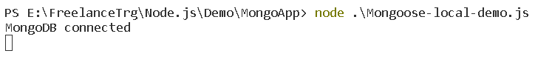
  - This connects to a local MongoDB database named trgdb and logs a message to the console when the
connection is successful.
var express = require('express'); var app = express();
const mongoose = require('mongoose'); mongoose.connect('mongodb://127.0.0.1:27017/trgdb’,
{ useNewUrlParser: true, useUnifiedTopology: true })
.then(() => console.log('MongoDB connected'))
.catch((err) => console.log(err));

app.listen(3030);
useNewUrlParser: Set to true to use the new MongoDB connection string parser. useUnifiedTopology: Set to true to use the new Server Discovery and Monitoring engine.

- Step-2: Define a Mongoose schema for the data that will be stored in the DB

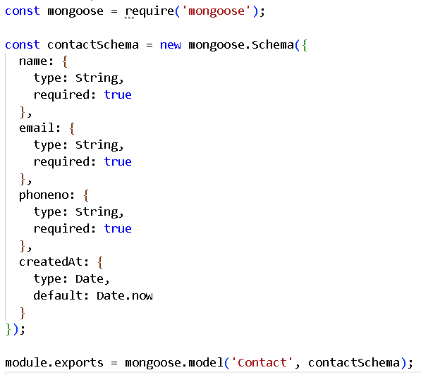
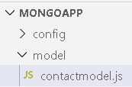
Schema is a representation of the structure of the data. It allows us to decide exactly what data we want, and what options we want the data to have as an object

The Schema allows you to define the fields stored in each document along with their validation requirements and default values

Schemas are "compiled" into models using the mongoose.model() method. Once you have a model you can use it to find, create, update, and delete objects of the given type.

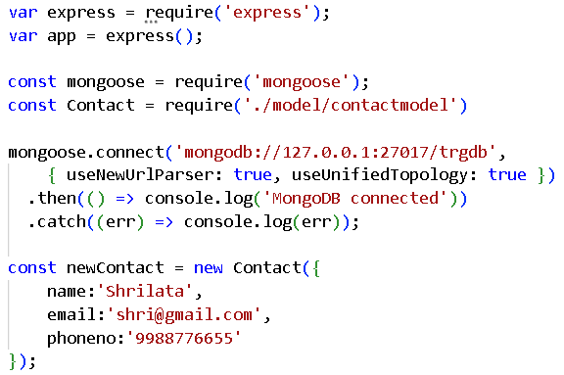
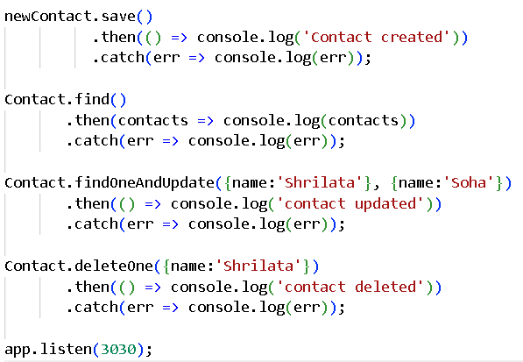
- Step-3 : Finally, use the defined schema to perform CRUD on documents in the DB
The Contact model is imported from the previously defined schema file
The methods are all provided by Mongoose and simplify the process of interacting with the database

Express Router
Express router is a class which helps us to create router

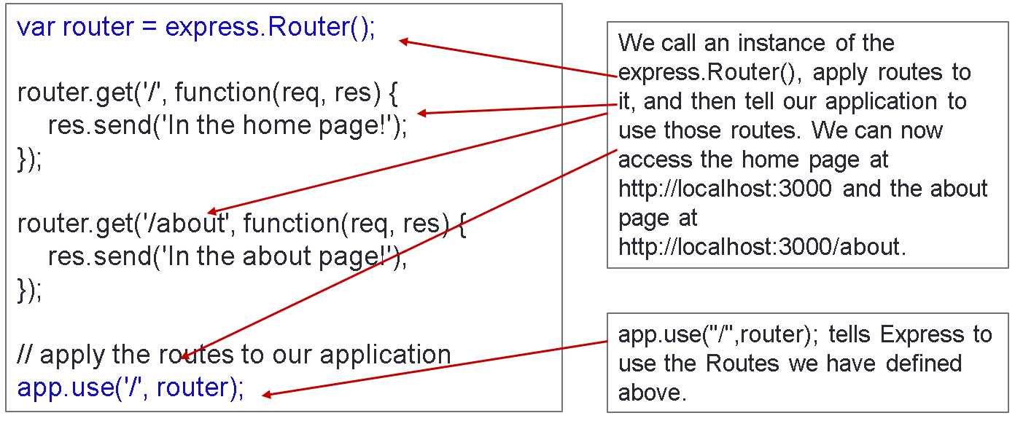
- Router is like a mini express application; capable only of performing middleware and routing functions. Every Express application has a built-in app router.

  - Notice how we set a default root for using these routes we just defined. If we had changed last
line to app.use('/app', router), then our routes would
be http://localhost:3000/app and http://localhost:3000/app/about.



//bookRoutes.js
const express = require("express"); const router = express.Router();

router.get("/books/:bid", function (req, res) { res.send("<h1>Sending book with ID : " + req.params.bid
+ "</h1>");
});

router.get("/books", function (req, res) { res.send("<h1>Sending list of all books</h1>");
});

router.post("/books", function (req, res) { res.send("<h1>created new book</h1>");
})

module.exports = router;
//route-demoapp.js
const express = require('express') const app = express()
const bookroutes = require("./routes/bookRoutes")

app.use("/book", bookroutes)

app.listen(3000, ()=>{
console.log("Server listening on http://localhost:3000")
})

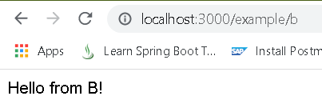
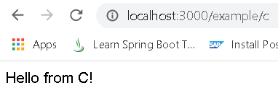
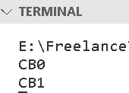
//More than one callback function can handle a route
app.get('/example/b', function (req, res, next) {
console.log('the response will be sent by the next function ...') next()
}, function (req, res) { res.send('Hello from B!')
})

//An array of callback functions can handle a route. var cb0 = function (req, res, next) {
console.log('CB0') next()
}

var cb1 = function (req, res, next) { console.log('CB1')
next()
}

var cb2 = function (req, res) { res.send('Hello from C!’)
}

app.get('/example/c', [cb0, cb1, cb2])

- Types of middleware: Application-level, Third-party, Router-level, Built-in, Error handling
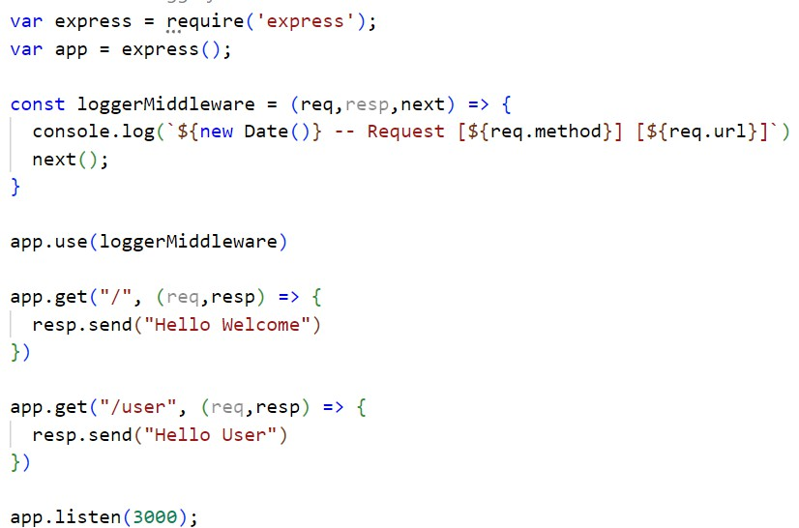
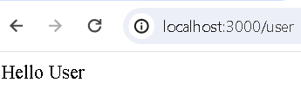
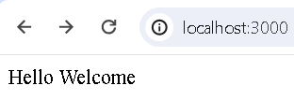

var express = require('express');
var app = express();
var router = express.Router();

const fakeAuth = (req, resp, next) => { const authStatus = false (/or true) if (authStatus) {
console.log("Auth status : ", authStatus) next();

Router level middleware

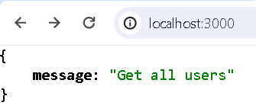
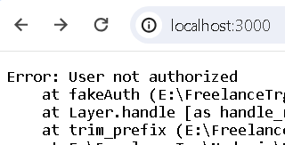
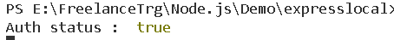
}
else {
resp.status(401)
throw new Error("User not authorized")
}
}
router.use(fakeAuth)

router.get('/', function (req, res) { res.json({ message: "Get all users" })
});

router.post('/', function (req, res) { res.json({ message: "Create new user" })
});

app.use('/', router);

app.listen(3000);

- A template engine facilitates you to use static template files in your applications.
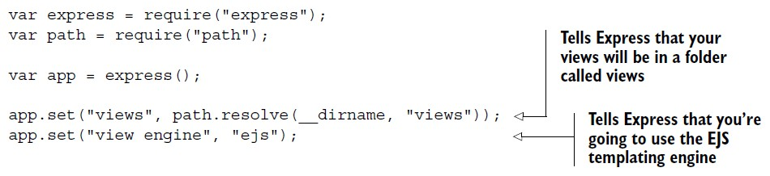
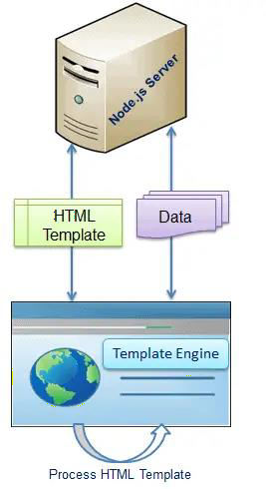
  - At runtime, it replaces variables in a template file with actual values, and transforms the template into an HTML file sent to the client.
  - This approach makes it easier to design an HTML page.
  - Some popular template engines that work with Express are Pug, Mustache, Haml, EJS, Jade, Vash, Handlebars etc

- Using EJS:
  - install ejs : npm install ejs –save
  - Create a folder called “views” in main project folder

To run this code, first create package.json and
add a property : "type": "module"
- As our application grows bigger, we want to split it into multiple files, so called “modules”.
  - A module may contain a class or a library of functions for a specific purpose.
  - A module is just a .js file
  - export keyword labels variables and functions that should be accessible from outside the current module.
  - import allows the import of functionality from other modules.
//TestModule.js
import { greetUser, name, sum } from "./module.js";

console.log(name) console.log(greetUser("Shrilata")) console.log("Sum is ", sum(10,20))
// module.js
export function greetUser(name) { return `Hello ${name}`;
}

// exporting a variable
export const name = 'Shrilata’;

// exporting a function export function sum(x, y) {
return x + y;
}

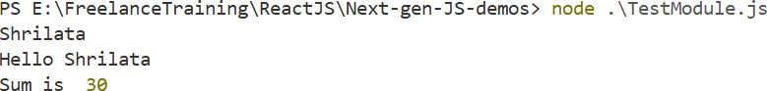

//def_module.js function greet(){
return "Hello User"
}
export default greet;
//TestModule.js
import helloFunc from "./def_module.js" console.log(helloFunc()) //Hello User
//MathModule.js
export function sum(a,b){
return a + b
}

export function mul(a,b){ return a * b
}

export const PI = 3.14
import * as math from "./MathModule.js" console.log(math.sum(math.PI, math.PI)) //6.28

console.log(math.mul(10,20)) //200

While performing default export,
“module” is imported from greet.js. Since, module is not in greet.js, the default export (greet() in this case) is exported as “module”.
You can directly use the default export without enclosing curly brackets {}.
A file can contain multiple exports. However, you can only have one default export in a file.

- To declare a class, you use the class keyword with the name of the class
- There can only be one "constructor" in a class; SyntaxError will be thrown if the class contains more than one occurrence of a constructor method.

class Rectangle { constructor(height, width) {
this.height = height; this.width = width;
}
}

constructor method is always defined with the name "constructor"
class Rectangle { constructor(height, width) {
this.height = height; this.width = width;
}

// Method calcArea() {
return this.height * this.width;
}
}

Classes can have methods, which defined as functions, albeit without needing to use the function keyword.
const square = new Rectangle(10, 10); console.log(square.calcArea()); // 100

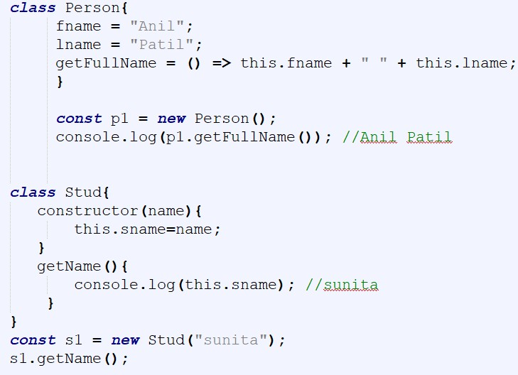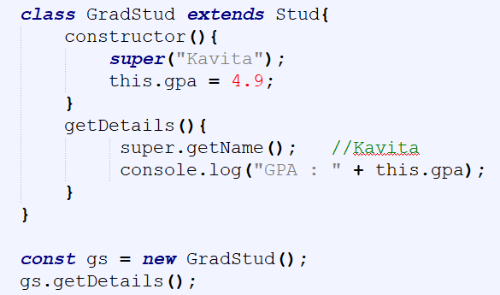

spread:
  - The spread operator is three dots (...) that perform several different tasks. The spread operator allows us to combine the contents of arrays. And Objects too
var peaks = ["Tallac", "Ralston", "Rose"] var canyons = ["Ward", "Blackwood"]
var tahoe = [...peaks, ...canyons] console.log(tahoe.join(', '))
// Tallac, Ralston, Rose, Ward, Blackwood
const arr = [2, 8, 15, 4];
Math.max(...arr); // 15
Math.min(...arr); // 2
We can use for loop to loop through each value of the array and find the max or min value. But using a spread operator we can do it in a single line.

var enhancedUser = { isAdmin : true,
var user = {
uname : "Soha",
email : "soha@gmail.com"
}
const nos = [1,2,3] const nos1 = [nos,4]
console.log(nos1) //[ [ 1, 2, 3 ], 4 ] const nos2 = [...nos, 4] console.log(nos2) //[ 1, 2, 3, 4 ]
...user
}
console.log(enhancedUser)
//{ isAdmin: true, uname: 'Soha', email: 'soha@gmail.com' }

- rest operator : used to merge a list of function arguments into an array
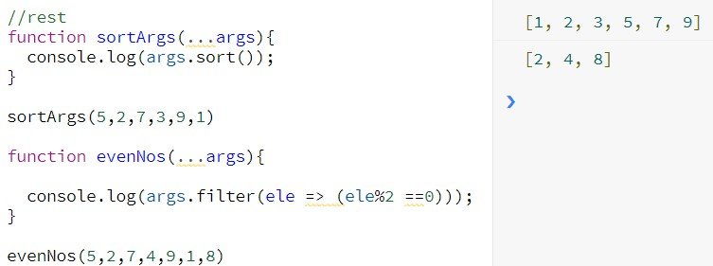

- Destructuring : allows to easily extract array elements or object properties and store them in variables
  - Allows you to do in a single line, what would otherwise require multiple lines
assign values to multiple variables in one line with array destructuring.
const arr=[1,2,3,4,5] var [a,b] = arr console.log(a,b) //1,2
//Destructuring arrays
const name = ["Anil", "Patil"]
// To access , we use name[0] and name[1]

//Instead we can do this:
const [fname, lname] = ["Anil","Patil"] console.log(fname, lname) //Anil Patil
//Shorthand
let [a, b, c] = [5, 8, 12];
//Longhand
let a, b, c;
a = 5;
b = 8;
c = 12;
  - We can

var rect = { x: 0, y: 10, width: 15, height: 20 };
// Destructuring assignment
var {x, y, width, height} = rect; console.log(x, y, width, height); // 0,10,15,20

- To swap two variables, we often use a third variable. We can swap two variables easily with array destructuring assignment.
let x = 'Hello', y = 55;
//Longhand const temp = x; x = y;
y = temp;

//Shorthand
[x, y] = [y, x];
- Object destructuring:
  - If the variable name and object key name are the same then we can just mention the variable name in object literals instead of both key and value.
  - JavaScript will automatically set the key same as the variable name and assign the value as a variable
value.
let firstname = 'Amitav'; let lastname = 'Mishra';
//Longhand
let obj = {firstname: firstname, lastname: lastname};
//Shorthand
let obj = {firstname, lastname};

- Array.filter
  - You can filter arrays by using the .filter(callback) method.
  - The result will be another array that contains 0 or more elements based on the condition (or the
"check") that you have in the callback.

var nums = [1, 2, 3, 21, 22, 30];
var evens = nums.filter(i => i % 2 == 0);
const grades = [10, 2, 21, 35, 50, -10, 0, 1];

//get all grades > 20
const result = grades.filter(grade => grade > 20); // [21, 35, 50];

// get all grades > 30
grades.filter(grade => grade > 30); // ([35, 50])

Array.map() : returns a new array containing the result of invoking the callback function for every item in the array.
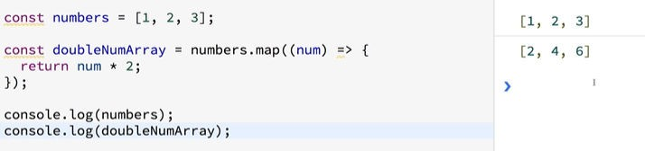
var numbers = [1, 2, 3, 4];
var doubled = numbers.map(i => i * 2);
var doubled = [for (i of numbers) i * 2]; //same as above console.log(doubled); // logs 2,4,6,8
var numbers = [1, 4, 9];
var roots = numbers.map(Math.sqrt);
console.log("roots is : " + roots ); //1,2,3

- Template strings provide us with an alternative to string concatenation. They also allow us to insert variables into a string.
  - Traditional string concatenation uses plus signs or commas to compose a string using variable values and strings.
  - console.log(lastName + ", " + firstName + “ “ + middleName)

- With a template, we can create one string and insert the variable values by surrounding them with ${variable}.
  - console.log(`${lastName}, ${firstName} ${middleName}`)
  - Any JavaScript that returns a value can be added to a template string between the ${ } in a template string.
//Javascript : generating an html string var msg1 = 'Have a great day';
var html = '<div>' + msg1 + '</div>';
document.write(html)

//Using template strings var msg2 = 'Never give up';
var html1 = `<div>${msg2}</div>`; document.write(html1)

